Skyline Web Tools
In the Skyline external tools framework, not only can you create installable script, but you can post arguments to a webpage.
For this tutorial you will need:
- Skyline
- SProCoP tutorial files (Skyline_SProCoP.sky)
- SProCoP external tool
Download the SProCoP tutorial file directory as well as the SProCoP tool zip file. Install SProCoP in Skyline Tool > External Tools > Add > From File.
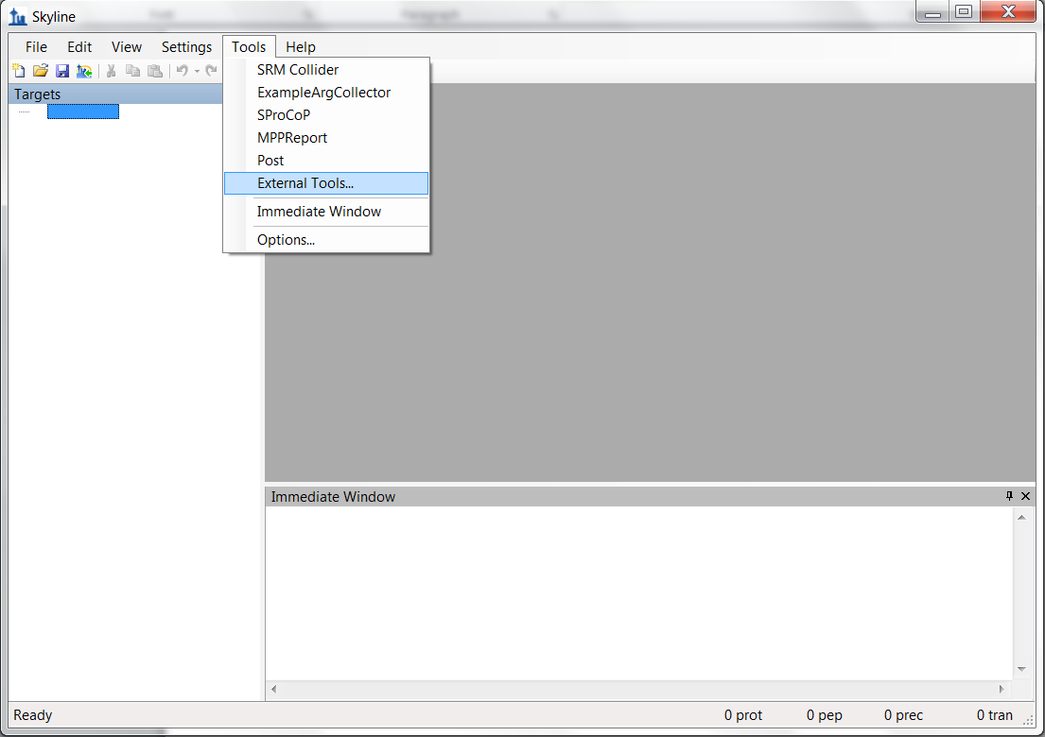
Once SProCoP and its required packages are installed File > Open up the Skyline_SProCoP.sky file in Skyline.

Setting up a web tool
To create your own web tool you will need a web server so for this tutorial we will set up the tool using https://skyline.gs.washington.edu/labkey/postreport/home/begin.view?. If you open the webpage from here you will see “null” in the text area. This is because we are not passing any POST parameters to the page. To test this we can go ahead and open up Skyline Tool >External Tools > Add > Custom.
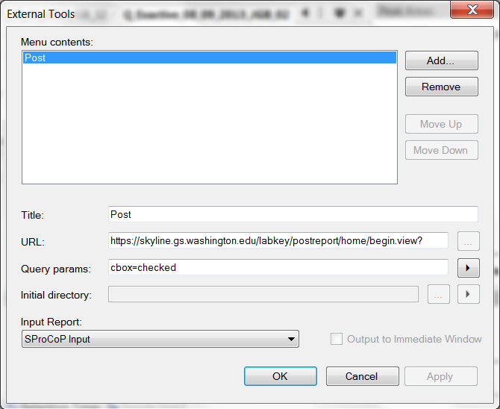
Figure 2 - Custom tool Post
Use figure 2 to create your new form. The title will be post, the command will be https://skyline.gs.washington.edu/labkey/postreport/home/begin.view?, the Query params will be ‘cbox=checked’, and the Input Report will be the SProCoP Input. Select ‘Ok’, and now your tool is set up.

Running a web tool
With the Skyline_SProCoP.sky file open in Skyline select Tools > Post.
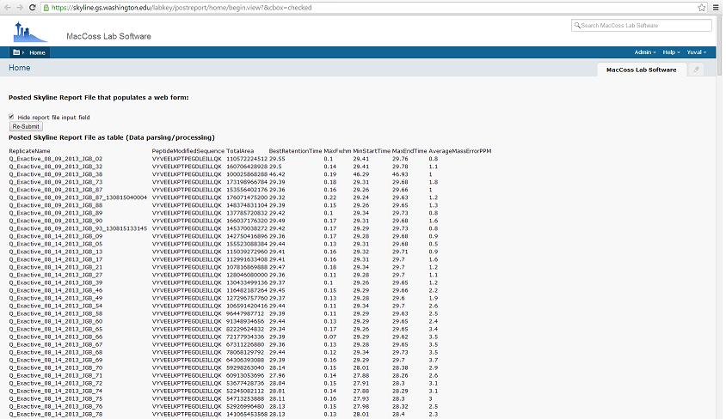
Figure 3 - HTML Web form populated with Skyline argument (Report) with cbox=checked Query parameter

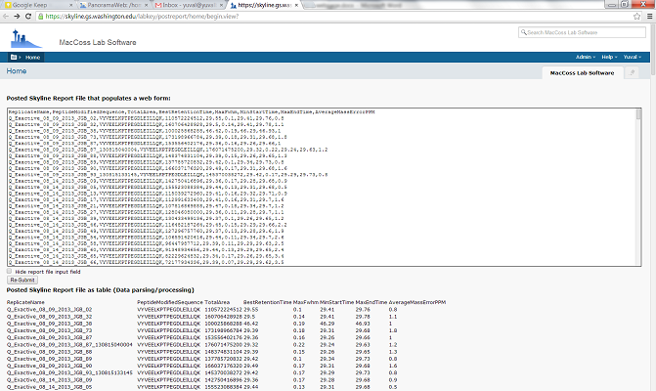
Figure 4 – HTML Web form populated with Skyline argument (Report)
When the Post tool is run a browser page will open and Skyline will post the arguments, which in this case was the SProCoP Input report to the webpage specified as the command. From there it is up to the webpage to know what to do with the data. In this example we created a simple web form which is populated by the post. The page also accepts a “cbox” parameter which if checked will hide the form, the data is still all there. This is a very simple web form which collects two post parameters, “SkylineReport”, and “cbox”, but Skyline can send as many arguments as needed. With the release of Skyline v2.5 users can now not only post a report but any additional arguments from the “Query Params” input.
In this case once the data is posted to the page Java handles the raw report file data and creates an organized table printed below the form. With this method it is possible to collect the skyline report from users, hide the data in an input, and add other argument inputs on the webpage for the users to specify additional arguments. When the users submit this form the back-end will have all the skyline report data along with the additional inputs added to the form.
A web tool can be packaged up in a tool zip file structure for use in the Skyline Tool Store, see the Skyline External Tools documentation.

