This Does NOT upload to panorama
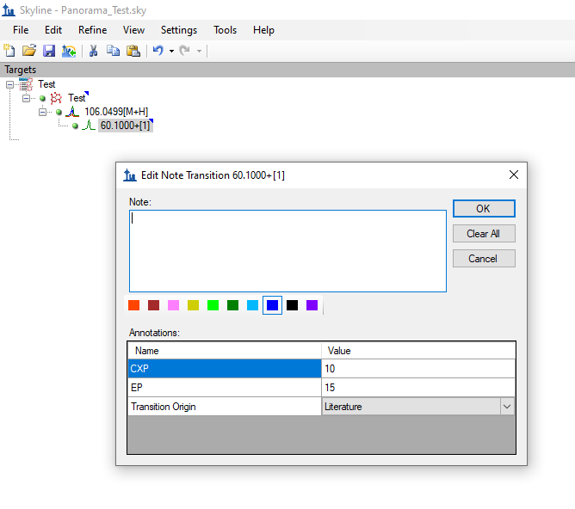
23 Mar 2020 12:22:03,602 INFO : Starting to run task 'org.labkey.targetedms.pipeline.TargetedMSImportTask' at location 'webserver-high-priority'
23 Mar 2020 12:22:03,612 INFO : Starting to import Skyline document from Panorama_Test_2020-03-23_12-20-46.sky.zip
23 Mar 2020 12:22:03,623 INFO : Expanding 20191028_Amyris_CenPK_DB.protdb
23 Mar 2020 12:22:04,997 INFO : Expanding Panorama_Test.skyd
23 Mar 2020 12:22:05,025 INFO : Expanding Panorama_Test.sky.view
23 Mar 2020 12:22:05,038 INFO : Expanding Panorama_Test.sky
23 Mar 2020 12:22:05,053 WARN : The version of this Skyline document is 20.1. This is newer than the highest supported version 4.1
23 Mar 2020 12:22:05,068 INFO : 80% Done
23 Mar 2020 12:22:05,122 INFO : Inserting Test
23 Mar 2020 12:22:05,238 INFO : Failed to complete task 'org.labkey.targetedms.pipeline.TargetedMSImportTask'
23 Mar 2020 12:22:05,241 ERROR: SqlExecutor.execute(); uncategorized SQLException for SQL []; SQL state [25P02]; error code [0]; ERROR: current transaction is aborted, commands ignored until end of transaction block; nested exception is org.postgresql.util.PSQLException: ERROR: current transaction is aborted, commands ignored until end of transaction block
Caused by: org.postgresql.util.PSQLException: ERROR: current transaction is aborted, commands ignored until end of transaction block
Caused by: org.postgresql.util.PSQLException: ERROR: insert or update on table "transitionannotation" violates foreign key constraint "fk_transitionannotation_gtid"
Detail: Key (transitionid)=(0) is not present in table "generaltransition".
23 Mar 2020 12:22:05,303 ERROR: Uncaught exception in PipelineJob: (DONE) Skyline document import - Panorama_Test_2020-03-23_12-20-46.sky.zip
org.springframework.jdbc.UncategorizedSQLException: SqlExecutor.execute(); uncategorized SQLException for SQL []; SQL state [25P02]; error code [0]; ERROR: current transaction is aborted, commands ignored until end of transaction block; nested exception is org.postgresql.util.PSQLException: ERROR: current transaction is aborted, commands ignored until end of transaction block
Caused by: org.postgresql.util.PSQLException: ERROR: current transaction is aborted, commands ignored until end of transaction block
Caused by: org.postgresql.util.PSQLException: ERROR: insert or update on table "transitionannotation" violates foreign key constraint "fk_transitionannotation_gtid"
Detail: Key (transitionid)=(0) is not present in table "generaltransition".

This DOES upload to panorama (No transition Information)
