Document problem with Skyline on Agilent QQQ data with diverter valve on.

Ran standards in Agilent QQQ with diverter valve on from 0-0.2 mins to protect mass spec from salts. Afterwards, samples was going through mass spec from 0.2 to 5 mins.

When I ran the data in skyline, this is what I get:

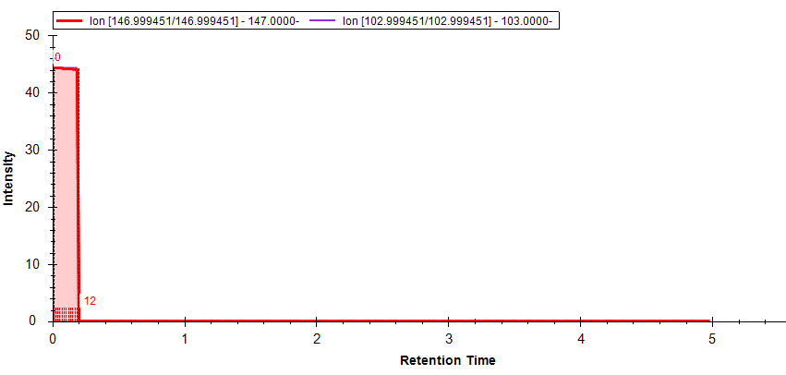

I tried to check the settings and ensure that I am importing Agilent data but that did not help.
Below is a small part of our transition list:

MoleculeGroup | PrecursorName | PrecursorMz | ProductMz | PrecursorCharge | ProductCharge
Positive | Phenylalanine | 166.1 | 120.1 | 1 | 1
Positive | Phenylalanine | 166.1 | 77.2 | 1 | 1
Positive | Phenylalanine | 166.1 | 103.1 | 1 | 1
Negative | Phenylalanine | 164.1 | 147 | -1 | -1
Negative | Phenylalanine | 164.1 | 103 | -1 | -1

Below is the data from Quant on phenylalanine in negative mode:
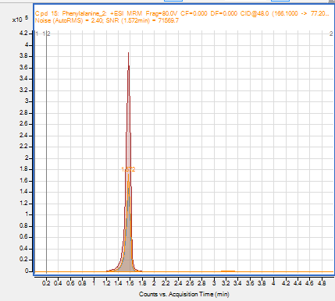

And so, skyline should be able to run this data as well.
Unfortunately, I cannot send you the data because Agilent data is in multiple folders.
But here are the snap shot of the individual folders:
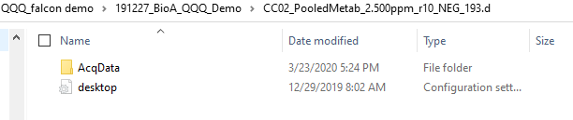
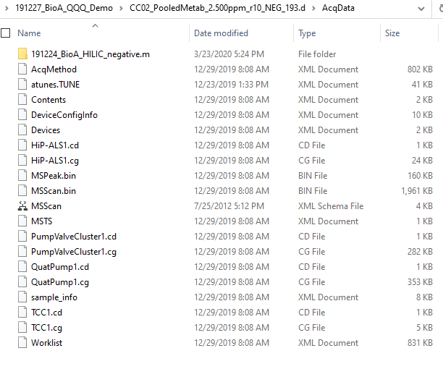

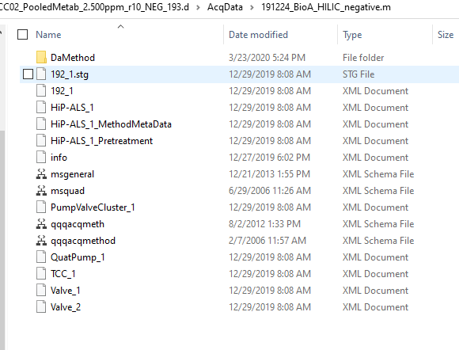

Below is an example of Agilent QQQ data without diverter valve:
