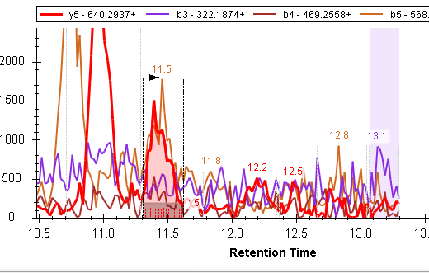
What this shade area stands for?
What red dot line and shade area stand for?
What two solid blue line mean?

