Why is the "Agilent Automation" feature not available on my skyline operation panel?

Hello

"I want to optimize CE using 'Automation' as shown in the figure."
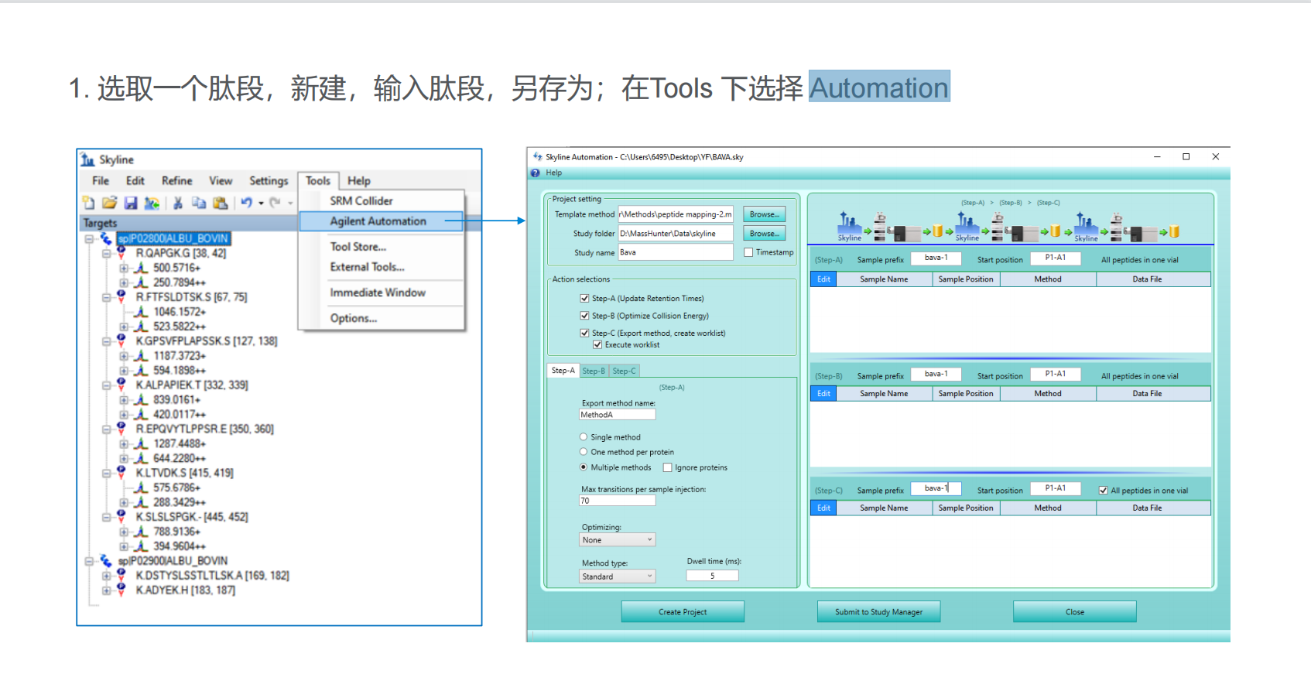
But why doesn't my operation panel have 'Automation'?
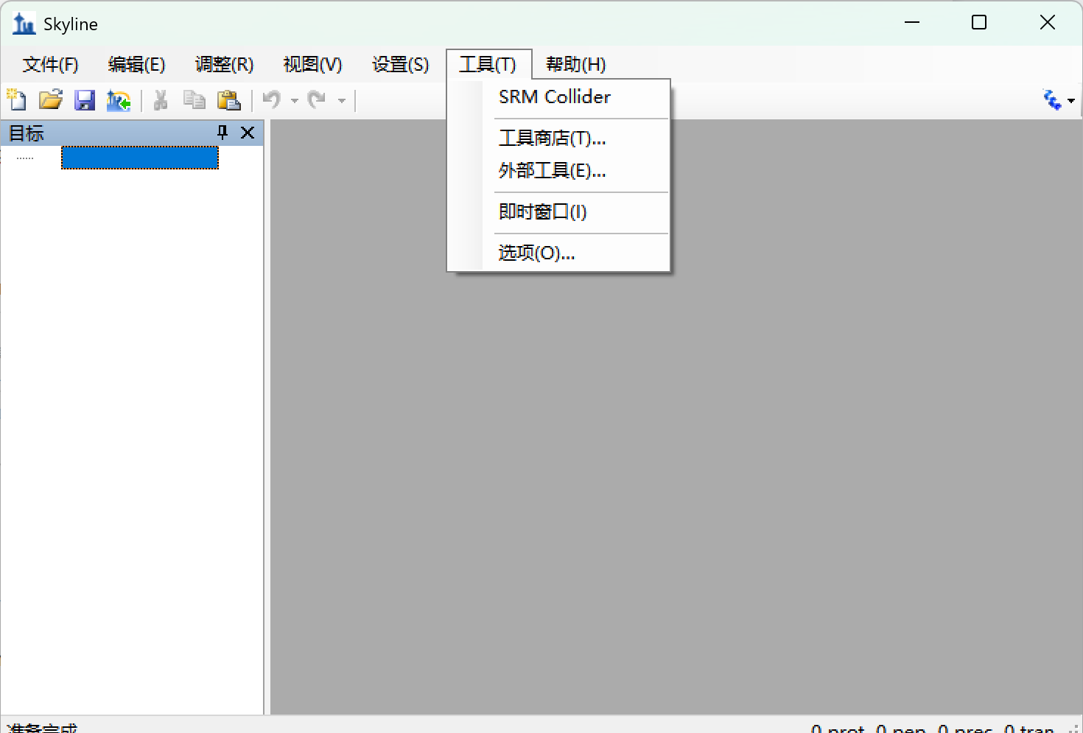

Thanks,
Zhaoxuanxuan

