PGD2 and PGE2 in raw data file
No Chromatogram for PGE2
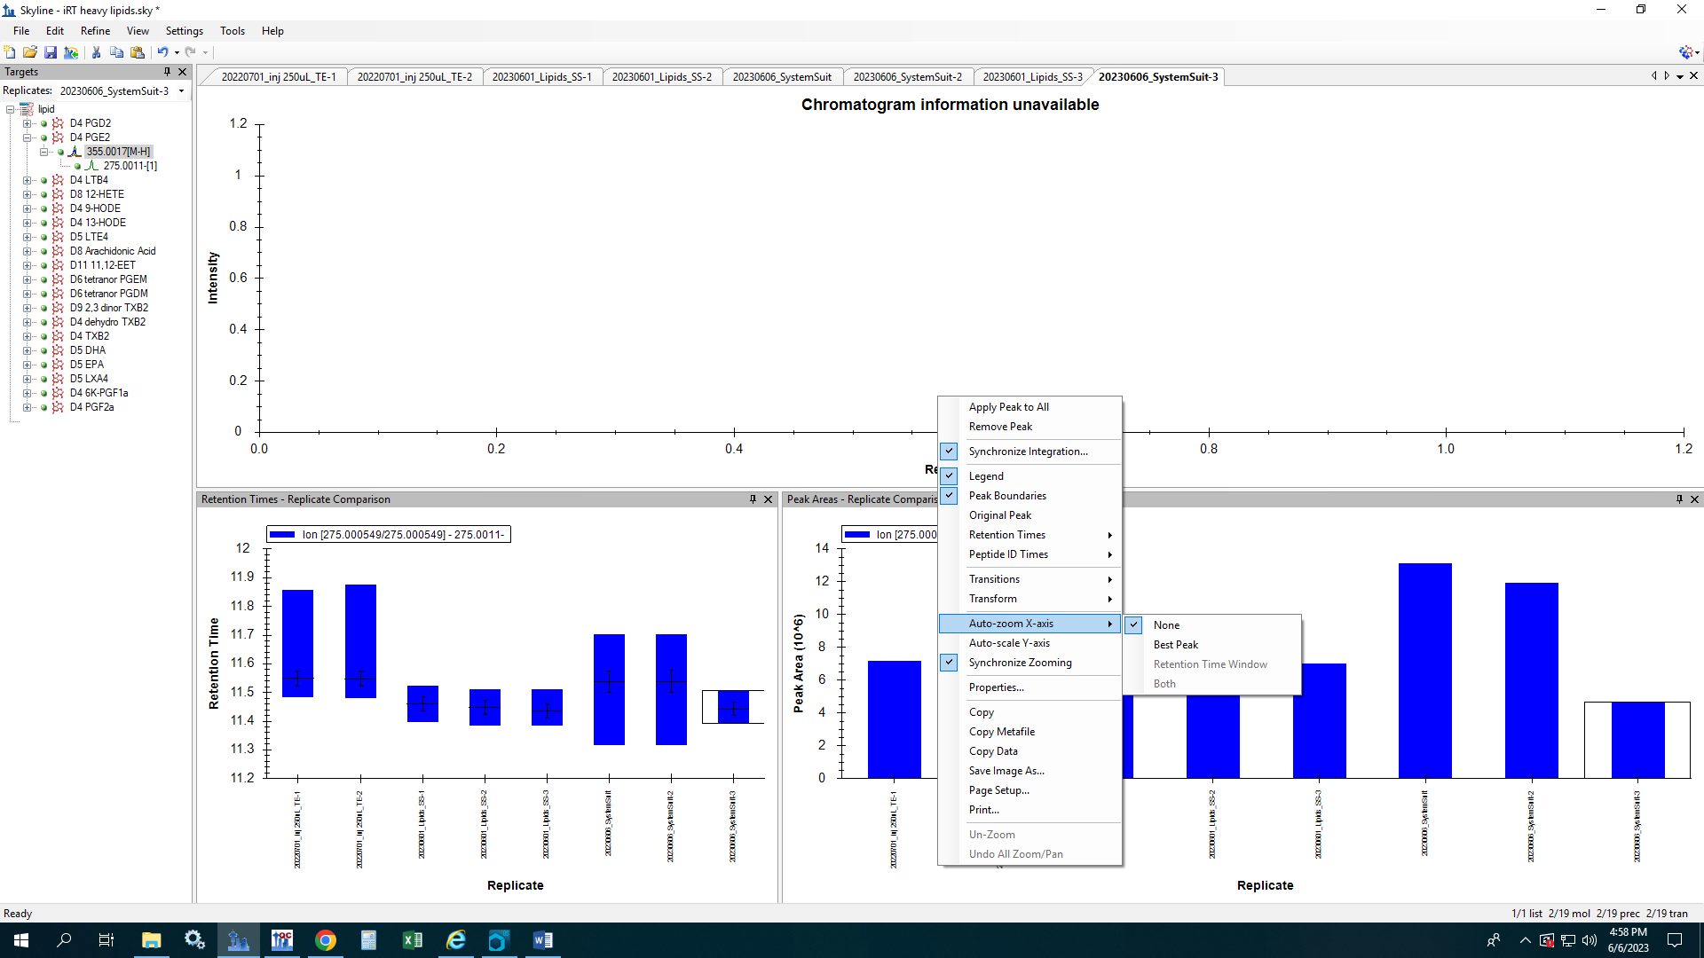
tPGEM in raw file
tPGEM cuts off in skyline (7.4min)
