- Open blank document and check that the document is in “proteomics” mode
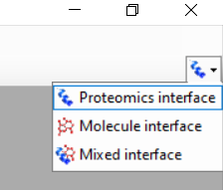
- Settings -> peptide settings
  - Digestion tab: Add a “No Enzyme” option in the enzyme drop down list, where it ‘cleaves’ at A, unless followed by ARNDCQEGHILKMFPSTWYV
    - For background proteome, import a FASTA file with human amelogenin protein sequences
  - Library tab: build a new library by adding DAT files from Mascot searched data (export Mascot identifications as DAT files and load into Skyline)
  - Modifications tab: unselect carbamidomethyl, and add an oxidation of methionine modification
- Settings -> transition settings
  - Full-scan tab: in the MS/MS filtering section, select DDA as acquisition method, and TOF as product mass analyzer
- Edit->insert->peptides
  - In the columns, type in
    - SMIRPPY | AMELY
    - SIRPPYPSYG | AMELX
    - SIRPPYPSYGYEPMG | AMELX
  - These peptides should now appear in the targets window
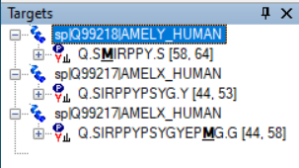
- This can then be exported as a transition list which creates an excel spreadsheet with all of the transitions Skyline will scan for
- File->import->results, click ok. You can then load in spectral data

