Question 1) I am trying to import my DDA result file into Skyline to build a DDA library for DIA analysis. It is a Proteome discoverer result file from several fractions, and PD has integrated them into one file. When I import the PD file, I got the following error message. What should I do?
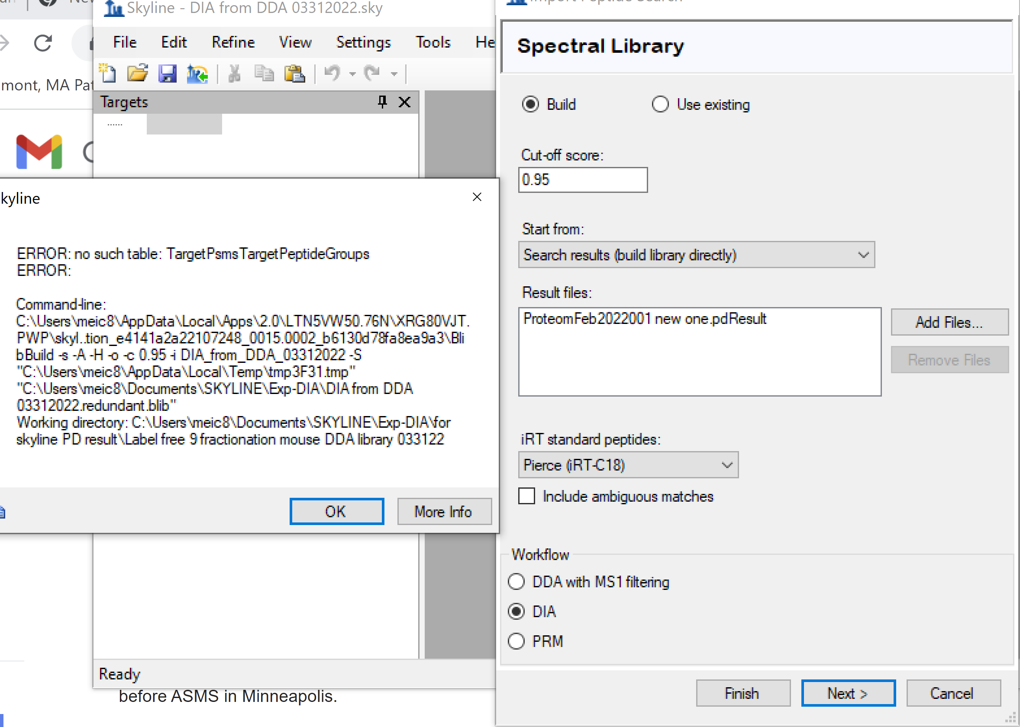
I am wondering if the Settings (Peptide Settings and Transition Settings) are supposed to set as defaults before building a DDA library for DIA analysis.

Question 2) This question is related to settings for PRM. In the Library under Peptide Settings, I want to “Build” a library from a Proteome Discovery result file I generated. But I got the similar error message as above:
