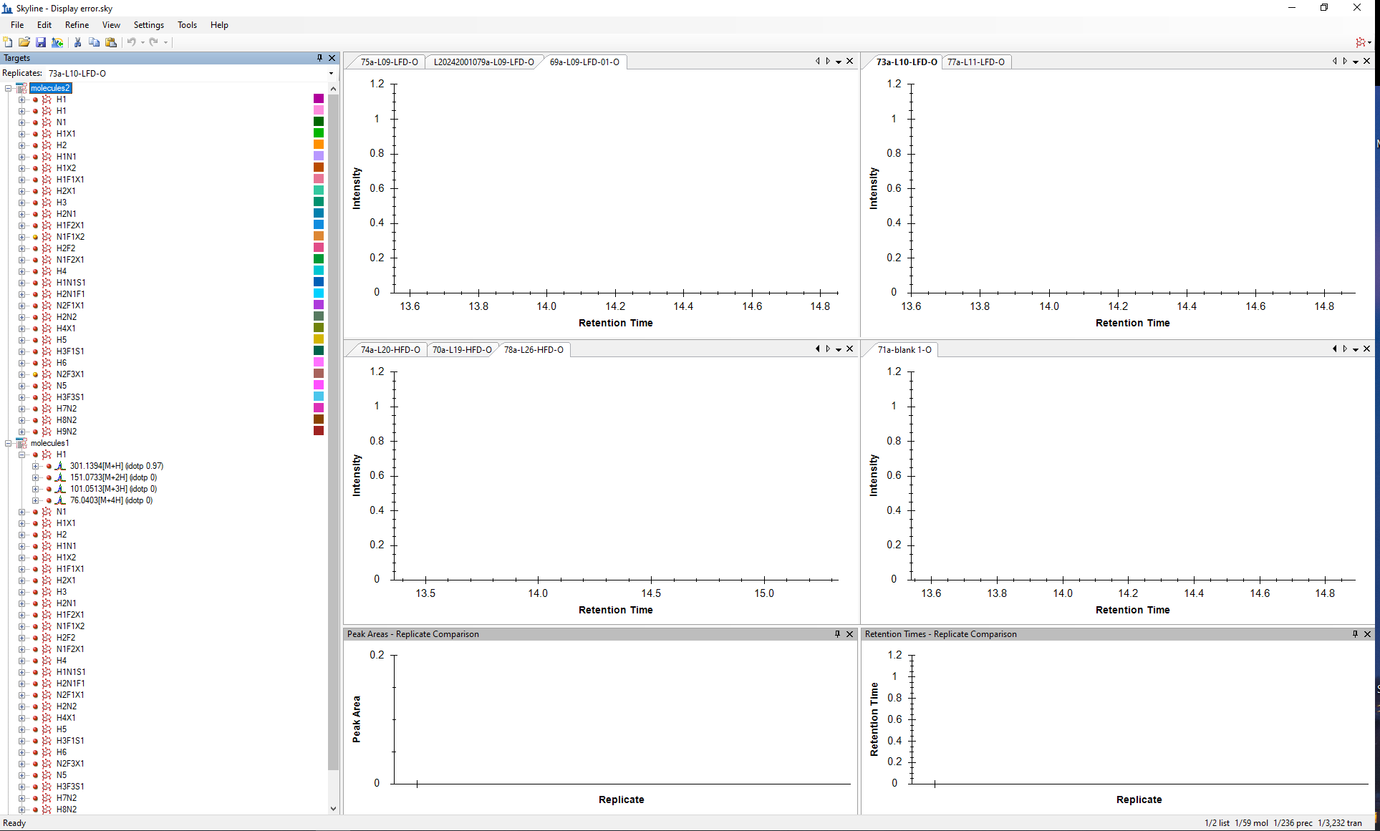
There’s nothing in the view when whole glycans were selected.
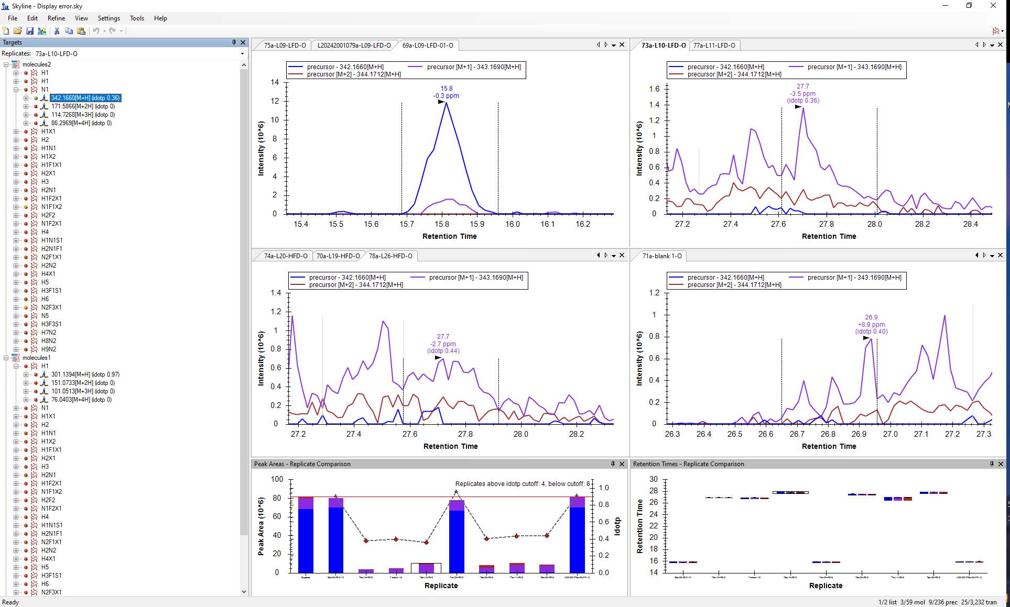
All the stuff showed up when one of the glycan is selected.
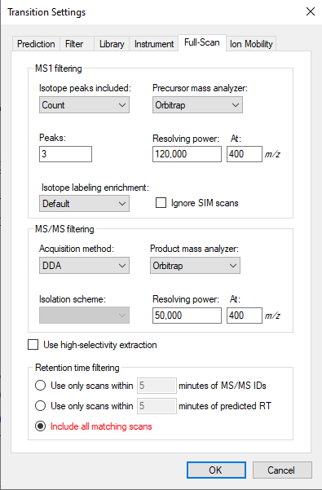
My transition setting.

