Suggestion for graph arrangement (Thomas)

View > Arrange Graphs > Grouped …

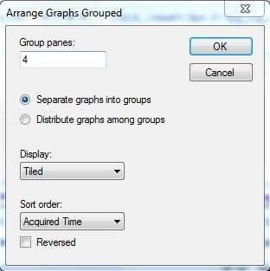

- Separate graphs…
- Distribute…
- ‘Advanced / Custom’ >>>

Group | Sample
1 | HCy (select sample from drop-down menu)
1 | A1
1 | A2
1 | A3
2 | B1
2 | B2
2 | B3
3 | C1
3 | C2
4 | Blank

