Edition Windows 10 Pro
Version 21H2
Installed on ‎3/‎28/‎2022
OS build 19044.1586
Experience Windows Feature Experience Pack 120.2212.4170.0
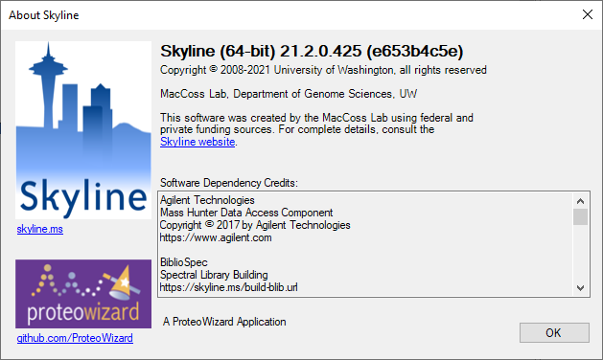
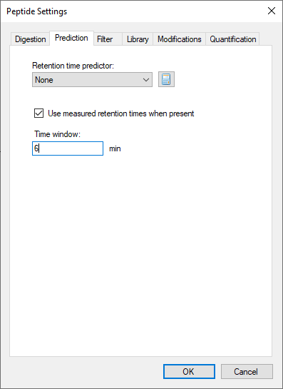
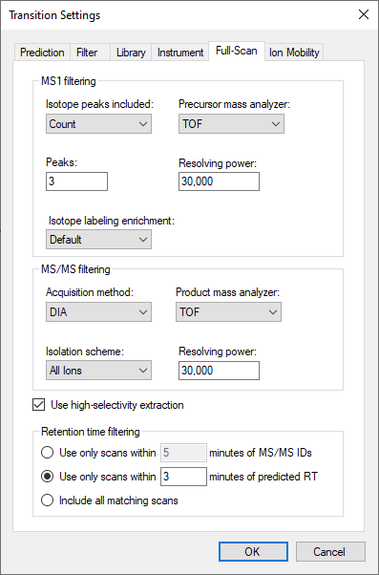
I’m trying to generate a mobility library so far I have curated my target peptides and transitions. I also made the following changes shown in the screenshots below before reimporting.
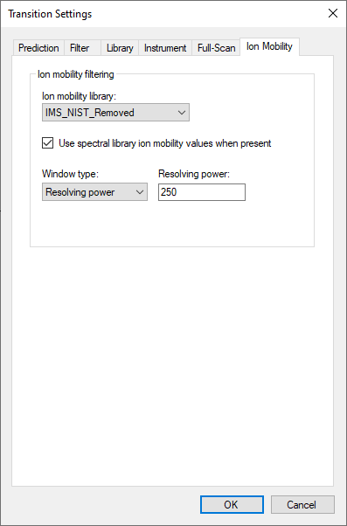
but when I attempt to reimport I run into the following error:
At 1:36 PM:
Failed importing results file 'C:\Users\alan.mckenzie-coe\OneDrive - MOBILion Systems, Inc\Documents\MAF\BATL\20min\Preprocess\Smoothed\NIST Digest 1.d'.
[MidacDataImpl::ccsToDriftTime()] Cannot solve cubic fit, solution not found within bounds [10 ms, 2000 ms].
pwiz.Skyline.Model.Results.ChromCacheBuildException: Failed importing results file 'C:\Users\alan.mckenzie-coe\OneDrive - MOBILion Systems, Inc\Documents\MAF\BATL\20min\Preprocess\Smoothed\NIST Digest 1.d'.
[MidacDataImpl::ccsToDriftTime()] Cannot solve cubic fit, solution not found within bounds [10 ms, 2000 ms]. ---> System.Exception: [MidacDataImpl::ccsToDriftTime()] Cannot solve cubic fit, solution not found within bounds [10 ms, 2000 ms].
at pwiz.CLI.analysis.SpectrumList_IonMobility.ccsToIonMobility(Double ccs, Double mz, Int32 charge)
at pwiz.ProteowizardWrapper.MsDataFileImpl.IonMobilityFromCCS(Double ccs, Double mz, Int32 charge) in C:\proj\skyline_21_2_x64\pwiz_tools\Shared\ProteowizardWrapper\MsDataFileImpl.cs:line 535
at pwiz.Skyline.Model.DocSettings.TransitionIonMobilityFiltering.GetIonMobilityFilter(LibKey ion, Double mz, IIonMobilityFunctionsProvider ionMobilityFunctionsProvider) in C:\proj\skyline_21_2_x64\pwiz_tools\Skyline\Model\DocSettings\TransitionIonMobilityFiltering.cs:line 143
at pwiz.Skyline.Model.DocSettings.TransitionIonMobilityFiltering.GetIonMobilityFilter(LibKey ion, Double mz, IIonMobilityFunctionsProvider ionMobilityFunctionsProvider, Double ionMobilityRangeMax) in C:\proj\skyline_21_2_x64\pwiz_tools\Skyline\Model\DocSettings\TransitionIonMobilityFiltering.cs:line 194
at pwiz.Skyline.Model.DocSettings.SrmSettings.GetIonMobilityHelper(PeptideDocNode nodePep, TransitionGroupDocNode nodeGroup, IIonMobilityFunctionsProvider ionMobilityFunctionsProvider, LibraryIonMobilityInfo libraryIonMobilityInfo, Double ionMobilityMax) in C:\proj\skyline_21_2_x64\pwiz_tools\Skyline\Model\DocSettings\SrmSettings.cs:line 1057
at pwiz.Skyline.Model.DocSettings.SrmSettings.GetIonMobilityFilter(PeptideDocNode nodePep, TransitionGroupDocNode nodeGroup, TransitionDocNode nodeTran, LibraryIonMobilityInfo libraryIonMobilityInfo, IIonMobilityFunctionsProvider instrumentInfo, Double ionMobilityMax) in C:\proj\skyline_21_2_x64\pwiz_tools\Skyline\Model\DocSettings\SrmSettings.cs:line 1030
at pwiz.Skyline.Model.Results.SpectrumFilter..ctor(SrmDocument document, MsDataFileUri msDataFileUri, IFilterInstrumentInfo instrumentInfo, Nullable`1 maxObservedIonMobilityValue, IRetentionTimePredictor retentionTimePredictor, Boolean firstPass, GlobalChromatogramExtractor gce) in C:\proj\skyline_21_2_x64\pwiz_tools\Skyline\Model\Results\SpectrumFilter.cs:line 207
at pwiz.Skyline.Model.Results.SpectraChromDataProvider..ctor(MsDataFileImpl dataFile, ChromFileInfo fileInfo, SrmDocument document, IRetentionTimePredictor retentionTimePredictor, String cachePath, IProgressStatus status, Int32 startPercent, Int32 endPercent, IProgressMonitor loader) in C:\proj\skyline_21_2_x64\pwiz_tools\Skyline\Model\Results\SpectraChromDataProvider.cs:line 121
at pwiz.Skyline.Model.Results.ChromCacheBuilder.CreateSpectraChromProvider(MsDataFileImpl dataFile, ChromFileInfo fileInfo) in C:\proj\skyline_21_2_x64\pwiz_tools\Skyline\Model\Results\ChromCacheBuilder.cs:line 1262
at pwiz.Skyline.Model.Results.ChromCacheBuilder.BuildCache() in C:\proj\skyline_21_2_x64\pwiz_tools\Skyline\Model\Results\ChromCacheBuilder.cs:line 233
--- End of inner exception stack trace ---

