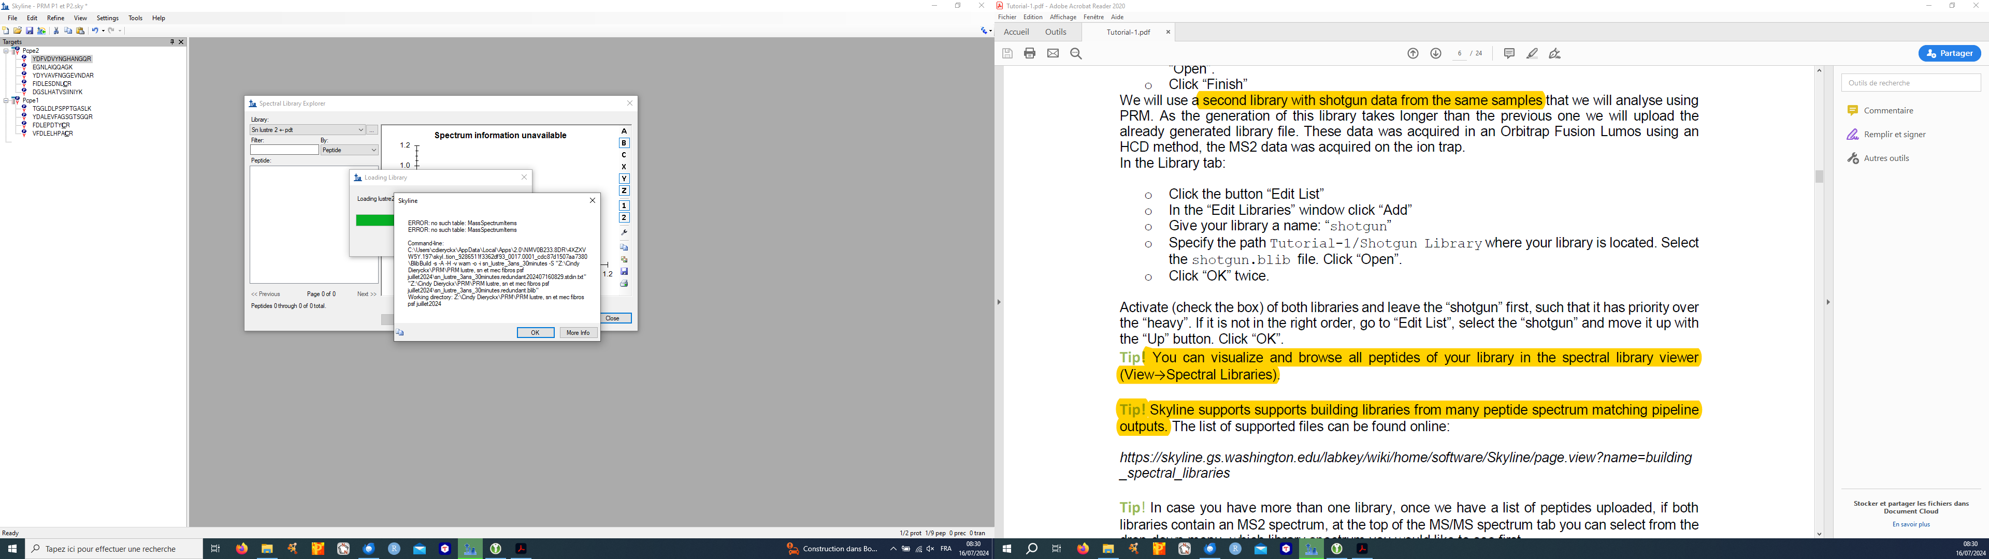

System.IO.IOException: ERROR: no such table: MassSpectrumItems

ERROR: no such table: MassSpectrumItems

Command-line: C:\Users\cdieryckx\AppData\Local\Apps\2.0\NMV0B233.8DR\4XZXVW5Y.197\skyl..tion_9286511f3362df93_0017.0001_cdc87d1507aa7380\BlibBuild -s -A -H -v warn -o -i sn_lustre_3ans -S "Z:\Cindy Dieryckx\PRM\PRM lustre, sn et mec fibros psf juillet2024\sn_lustre_3ans.redundant202407160845.stdin.txt" "Z:\Cindy Dieryckx\PRM\PRM lustre, sn et mec fibros psf juillet2024\sn_lustre_3ans.redundant.blib"

Working directory: Z:\Cindy Dieryckx\PRM\PRM lustre, sn et mec fibros psf juillet2024

à pwiz.Common.SystemUtil.ProcessRunner.Run(ProcessStartInfo psi, String stdin, IProgressMonitor progress, IProgressStatus& status, TextWriter writer, ProcessPriorityClass priorityClass, Boolean forceTempfilesCleanup, Func`3 outputAndExitCodeAreGoodFunc, Boolean updateProgressPercentage) dans C:\proj\skyline_23_1\pwiz_tools\Shared\Common\SystemUtil\ProcessRunner.cs:ligne 181

à pwiz.BiblioSpec.BlibBuild.BuildLibrary(LibraryBuildAction libraryBuildAction, IProgressMonitor progressMonitor, IProgressStatus& status, String& commandArgs, String& messageLog, String[]& ambiguous) dans C:\proj\skyline_23_1\pwiz_tools\Shared\BiblioSpec\BlibBuild.cs:ligne 433

à pwiz.Skyline.Model.Lib.BiblioSpecLiteBuilder.BuildLibrary(IProgressMonitor progress) dans C:\proj\skyline_23_1\pwiz_tools\Skyline\Model\Lib\BiblioSpecLiteBuilder.cs:ligne 161