**Nick is corrected. That was what happened.**

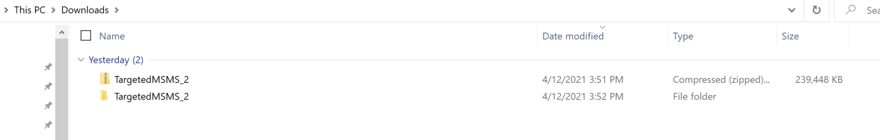

The first TargetedMSMS_2 (Zipped) folder is the download from Skyline, the second folder is the extracted folder generated on my PC (Window 10). Also, I downloaded Skyline 20.2-64 bit.

**The files in the zipped folder:**

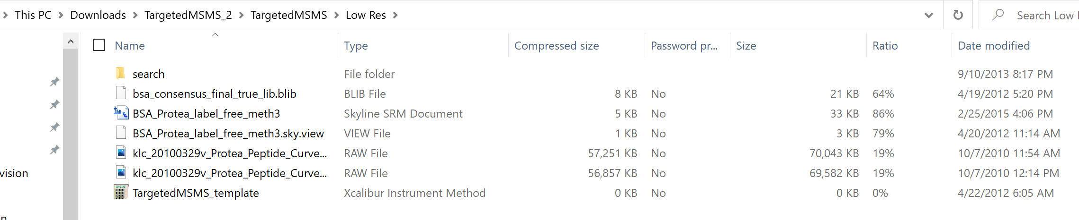

The files look almost the same as the extracted folder but missing one .slc file

**The files in the extracted folder:**

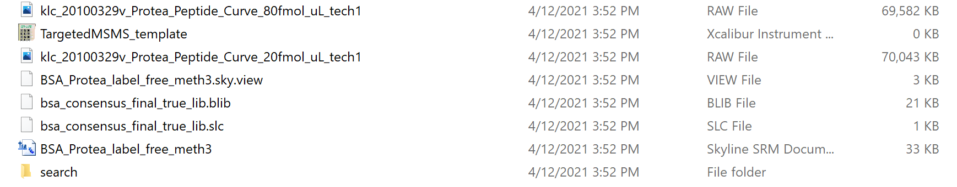

**There were no issues when I open the sky file from the extracted folder. I was able to work through the tutorial with no problem.**