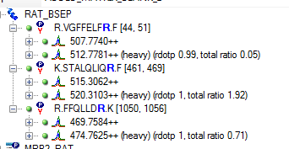

Above is just 1 out of 12 proteins in my list. There should be 334 transitions in my list but it isn’t exporting any of them.

