I tried to follow the toturial:



I double clicked on the BSA file

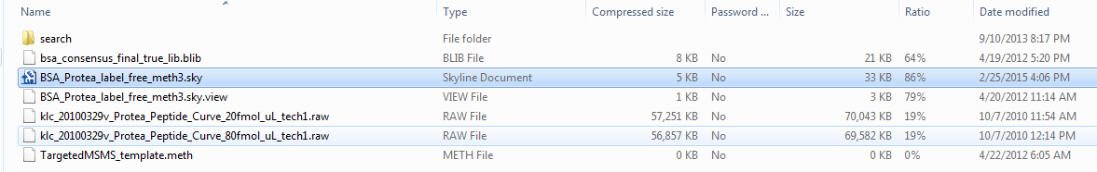

And saw this message

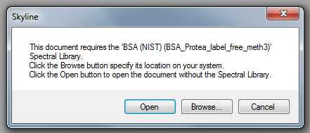

I did not see spectra display in Skyline

