Dear Skyline Team,
I am using a Bruker TimsTOF for proteomic analysis in PRM-PASEF mode and I would like to use the skyline software to optimize the collision energies of the produced ions. I have created a file taking into account the different collision energies to test per ion.

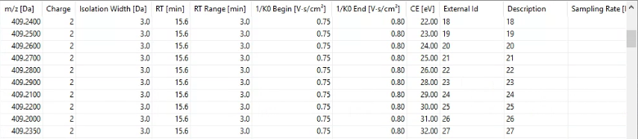

The acquisition went well and I managed to import the file on skyline.

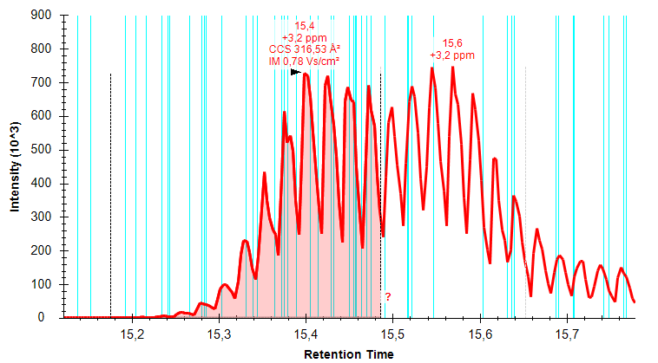
However, skyline refuses to display the full histogram for the different collision energies tested.

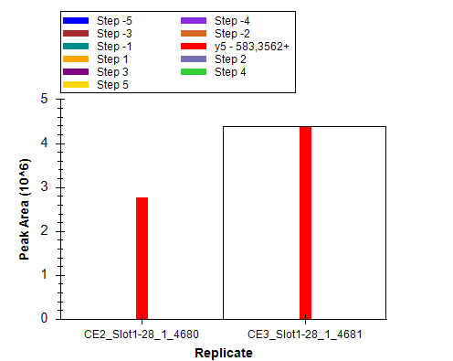
I would like to know if it is possible to optimize collision energies with a TimsTOF file on skyline.

Thank you very much for your help,
Kind regards,
Karweens

