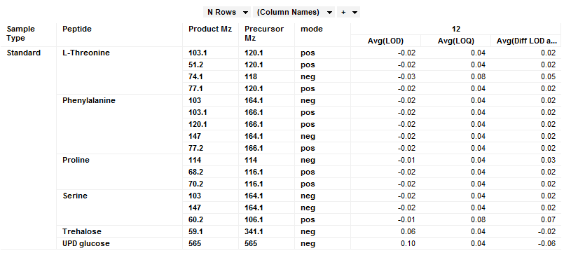

Above are the data that I am wondering about -LOD values and trehalose and UDP glucose are the ones that have LOQ lower than LOD.

