Hallo Skyline Team,
Since yesterday I started using skyline to check the MSMS spectra in my MIDAS runs (Sciex, MRM IDA runs, wiff files). The first data set worked fine. Then I started a second data set and Skyline did not find all the MRMs (I checked them in the Analyst software and they could be found), also the spectra were missing.
Analyst: the MRMs in question are: trypsin MRM 421.7/472.2
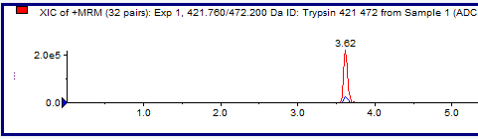
Skyline only finds the MRM 421.7/571.3 but not 472.28
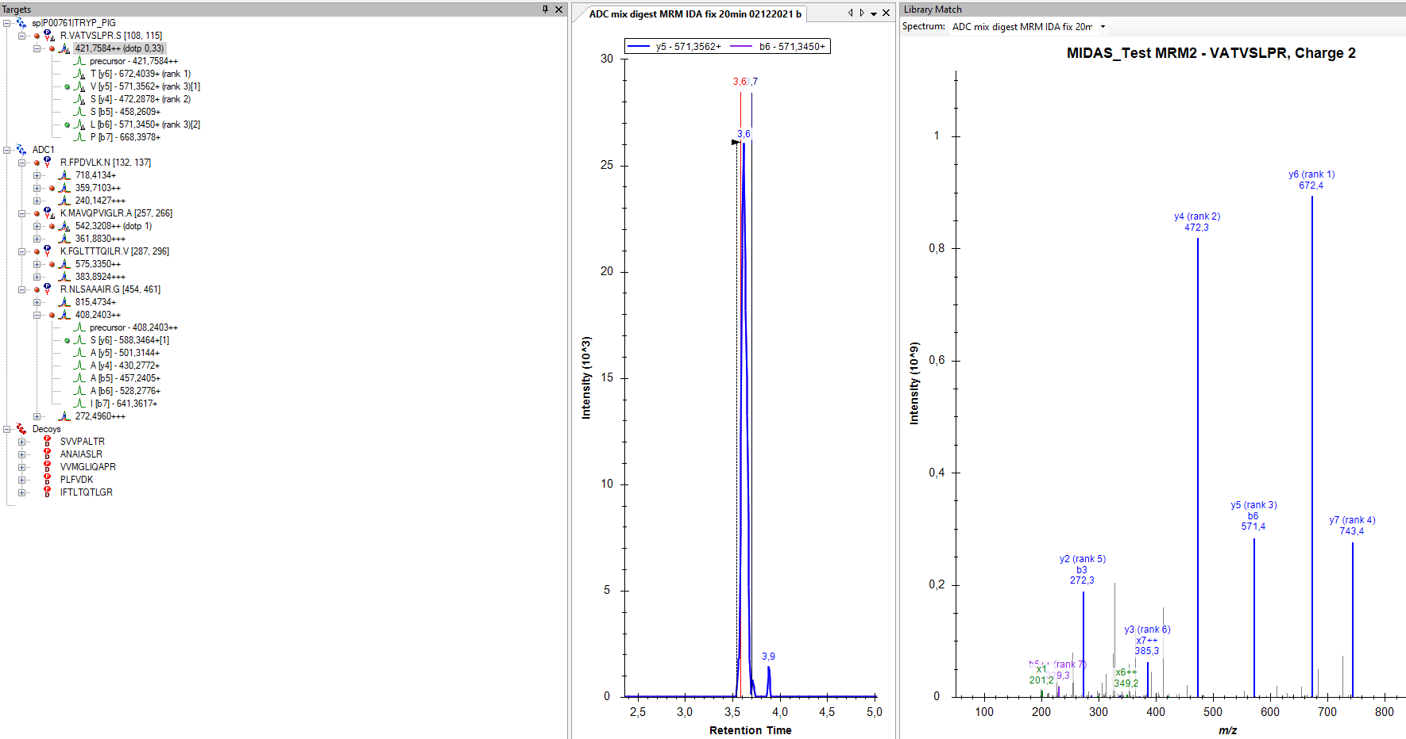
Analyst: the MRMs in question are: ADC1 MRM 542.3/654.4 and 782.8 again analyst finds both

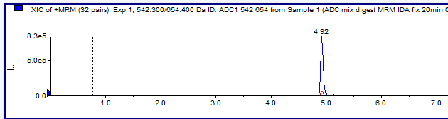

Skyline does not find it at all
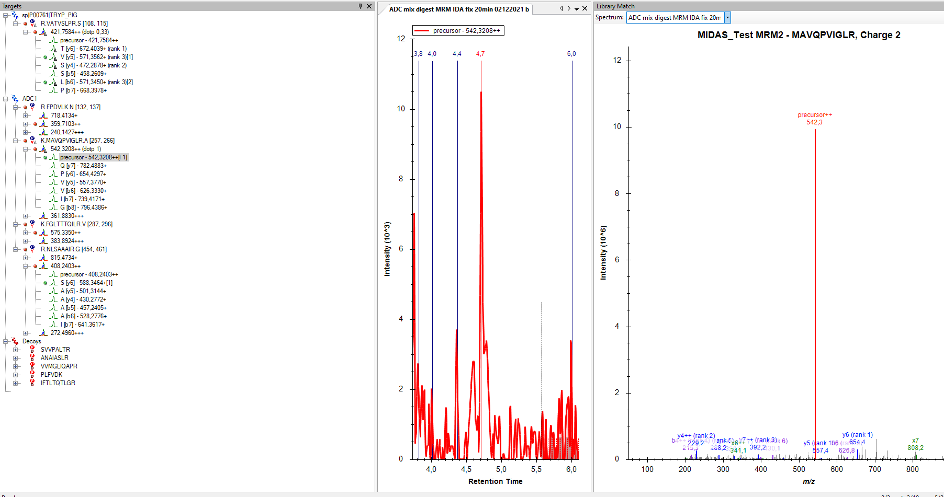

Analyst finds both MRMs 575.3/832.5 and 731.4
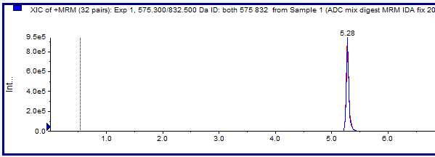
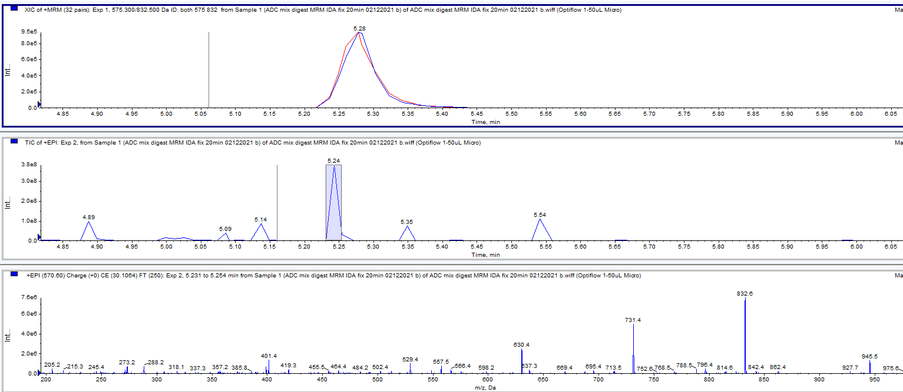
Skyline only finds 731.4 as the fragment and no spectrum and no 832 fragment.
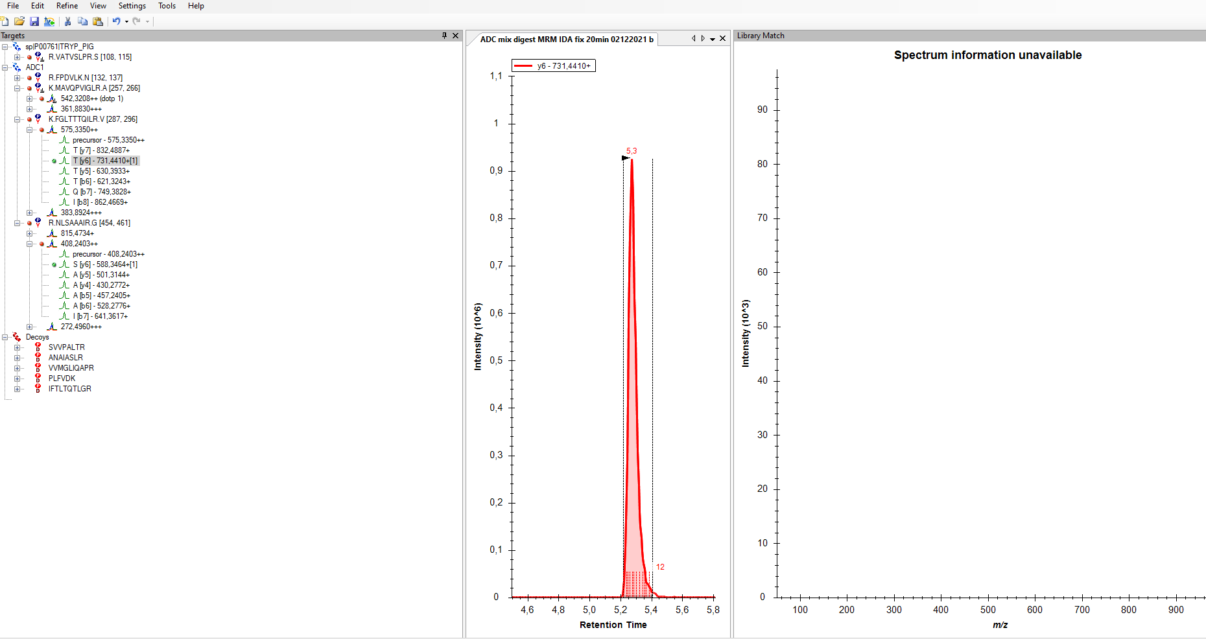

Analyst finds the 408.2/200.1 and 588.4 MRMs and the spectrum
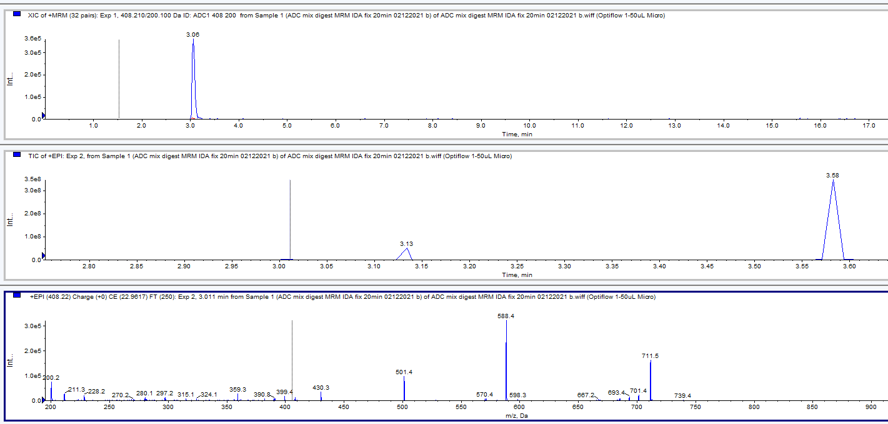
Skyline finds 408.2/588.4 but no spectrum
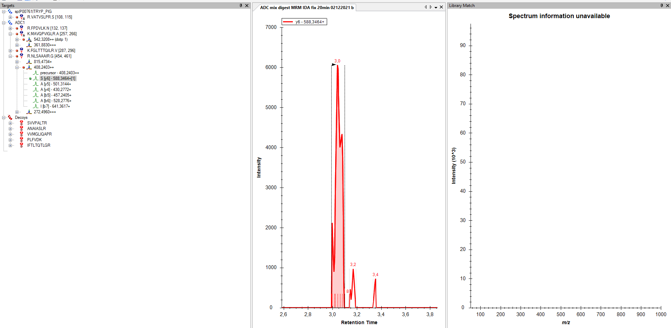

I am also a bit confused concerning the MIDAs runs (MRM triggers MSMS if a certain intensity is reached), if there are called a DDA or DIA or PRM experiment. I think they are data dependent, but as I said I might be wrong. I also made EMS IDA runs (MS1 triggers MSMS if a certain intensity is reached), which in my eyes would be a data independent run?
Thanks in advance for your time and help

Kind regards Edda

