Example 1
AutoQC EIC looks great:
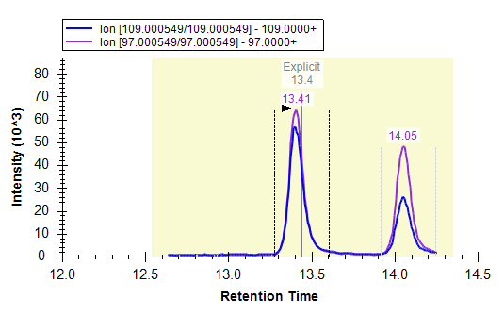

Retention time shift, AutoQC doesn’t integrate correct peak:
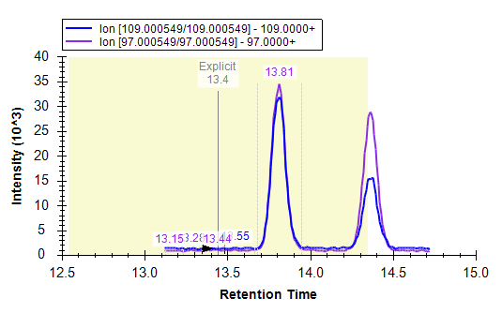

ZOOMED in_Retention time shift, AutoQC doesn’t integrate correct peak. Skyline is integrating noise, even though the correct peak at 13.81 minutes is within the explicit retention time window:
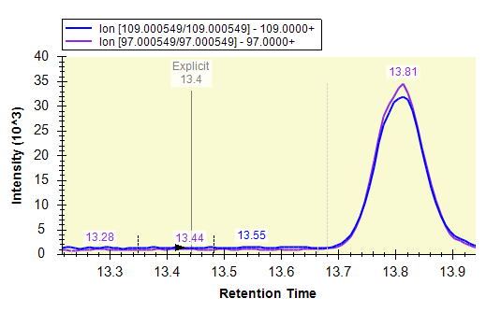
Example 2
AutoQC EIC looks great:
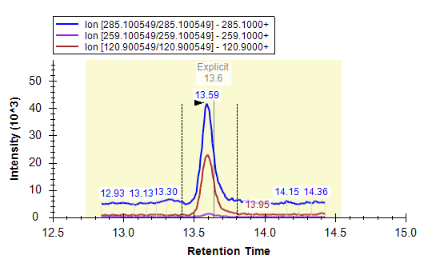

Retention time shift, AutoQC doesn’t integrate correct peak:

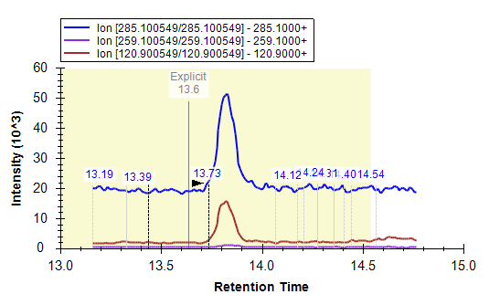

Example 3
AutoQC EIC looks great:
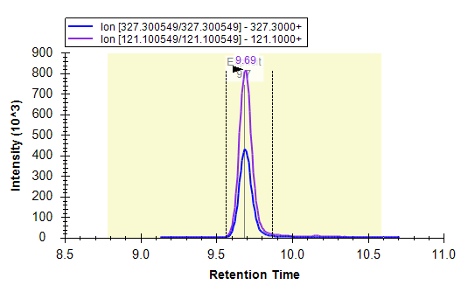

Retention time shift, AutoQC doesn’t integrate correct peak:
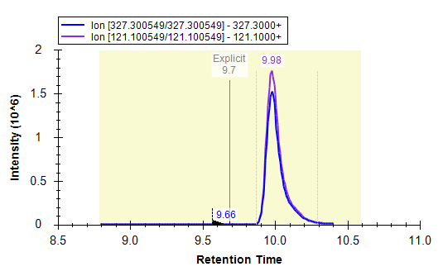
Retention time shift, AutoQC integrates correct peak. The RT is 9.98 just like the EIC above, yet this one was correctly integrated and the former ^^ was not:

