SKYLINE BUG for display and peak area reporting when Non-Quantitative transitions are included
Reported by: Will Thompson and Laura Dubois, Duke University, Jan 14, 2020
Skyline bug where Total Peak Area for the ‘heavy’ internal standard is somehow affected/changed based on what transitions are in the “light” version of the same molecule. This results in the exported and manually calculated ratio between analyte and internal standard not matching what is calculated in Skyline. There is also an affect on the display for the chromatogram peak areas.
Data file provided as demo: 5520_error_report_011420.sky.zip
To visualize the bug, open 5520_error_report_011420.sky.zip and open a document grid which contains each precursor, replicate, and the total peak area for each precursor. It should look something like this.
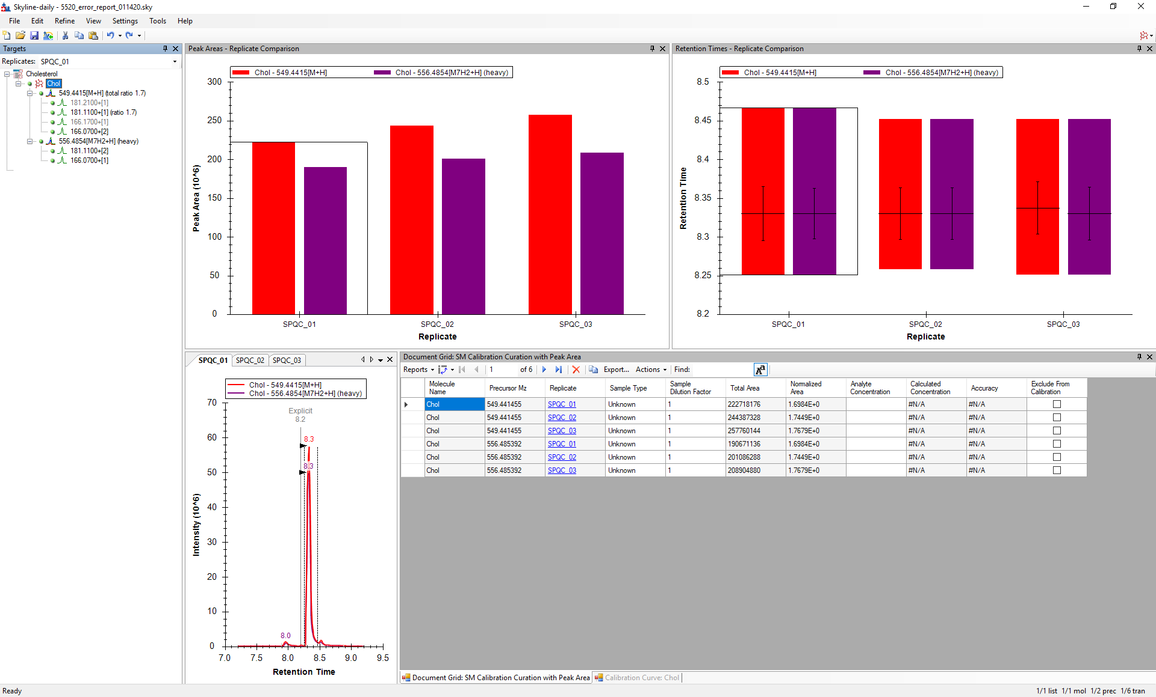
Notice that there are two “non quantitative transtions” for Cholesterol. We use these in the method to generate a ‘high’ and ‘low’ sensitivity method in a single analysis; the transitions are very close in m/z but not the same, and have a different collision energy. The method as provided is using the ‘detuned’ method, where two of the transitions have been excluded as quantitative. If you look closely at the data table, you will notice that the ratio of the total area light and total area heavy for the replicates DO NOT equal the “Normalized Area”:
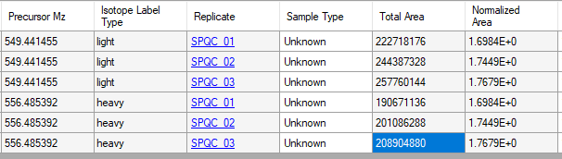
Just taking one example, for SPQC_01, Ratio of light to heavy is 222718176 / 190671136 = 1.16; NOT 1.69 as is reported in the “Normalized Area” tab. The initial question then, is ‘which one is right?”. A closer look, deleting the non-quantitative transitions from the document altogether, reveals some surprising and disconcerting changes:
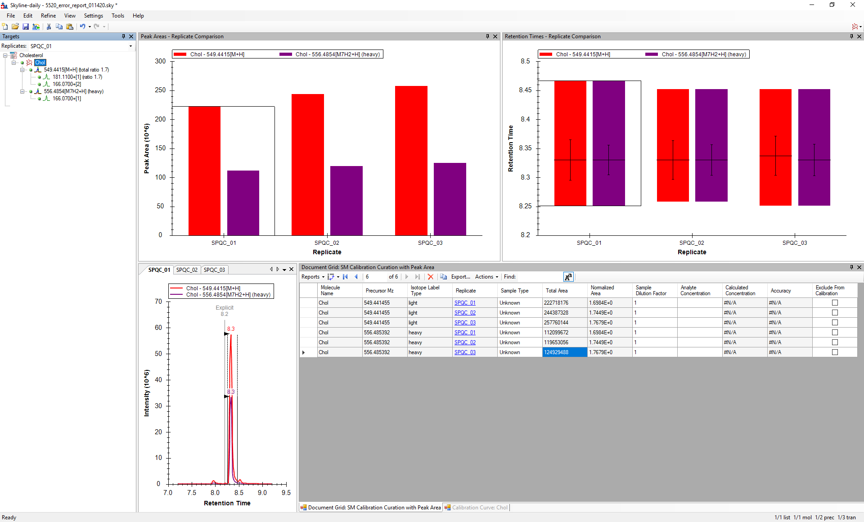
Note that not only does the peak area display change (which should not happen because the quantitative transitions were hidden from the document), it also changes the peak area visualization. More fascinating, if you look closely, is that even though we deleted transitions for the light molecule, the light peak area and chromatogram do not actually change intensity; instead deleting the two transitions from the light list actually change the displayed heavy transition peak area and the chromatographic peak. This is borne out in a change in the heavy peak areas in the table, and no change in the light peak areas.
The conclusion is that some peak areas are reported incorrectly, and visualized incorrectly, when non-quantitative transitions are included in the document. This will result in external analysis of peak area data being inconsistent with Skyline-calculated results.
