Sample 3 is the zeroed out sample.
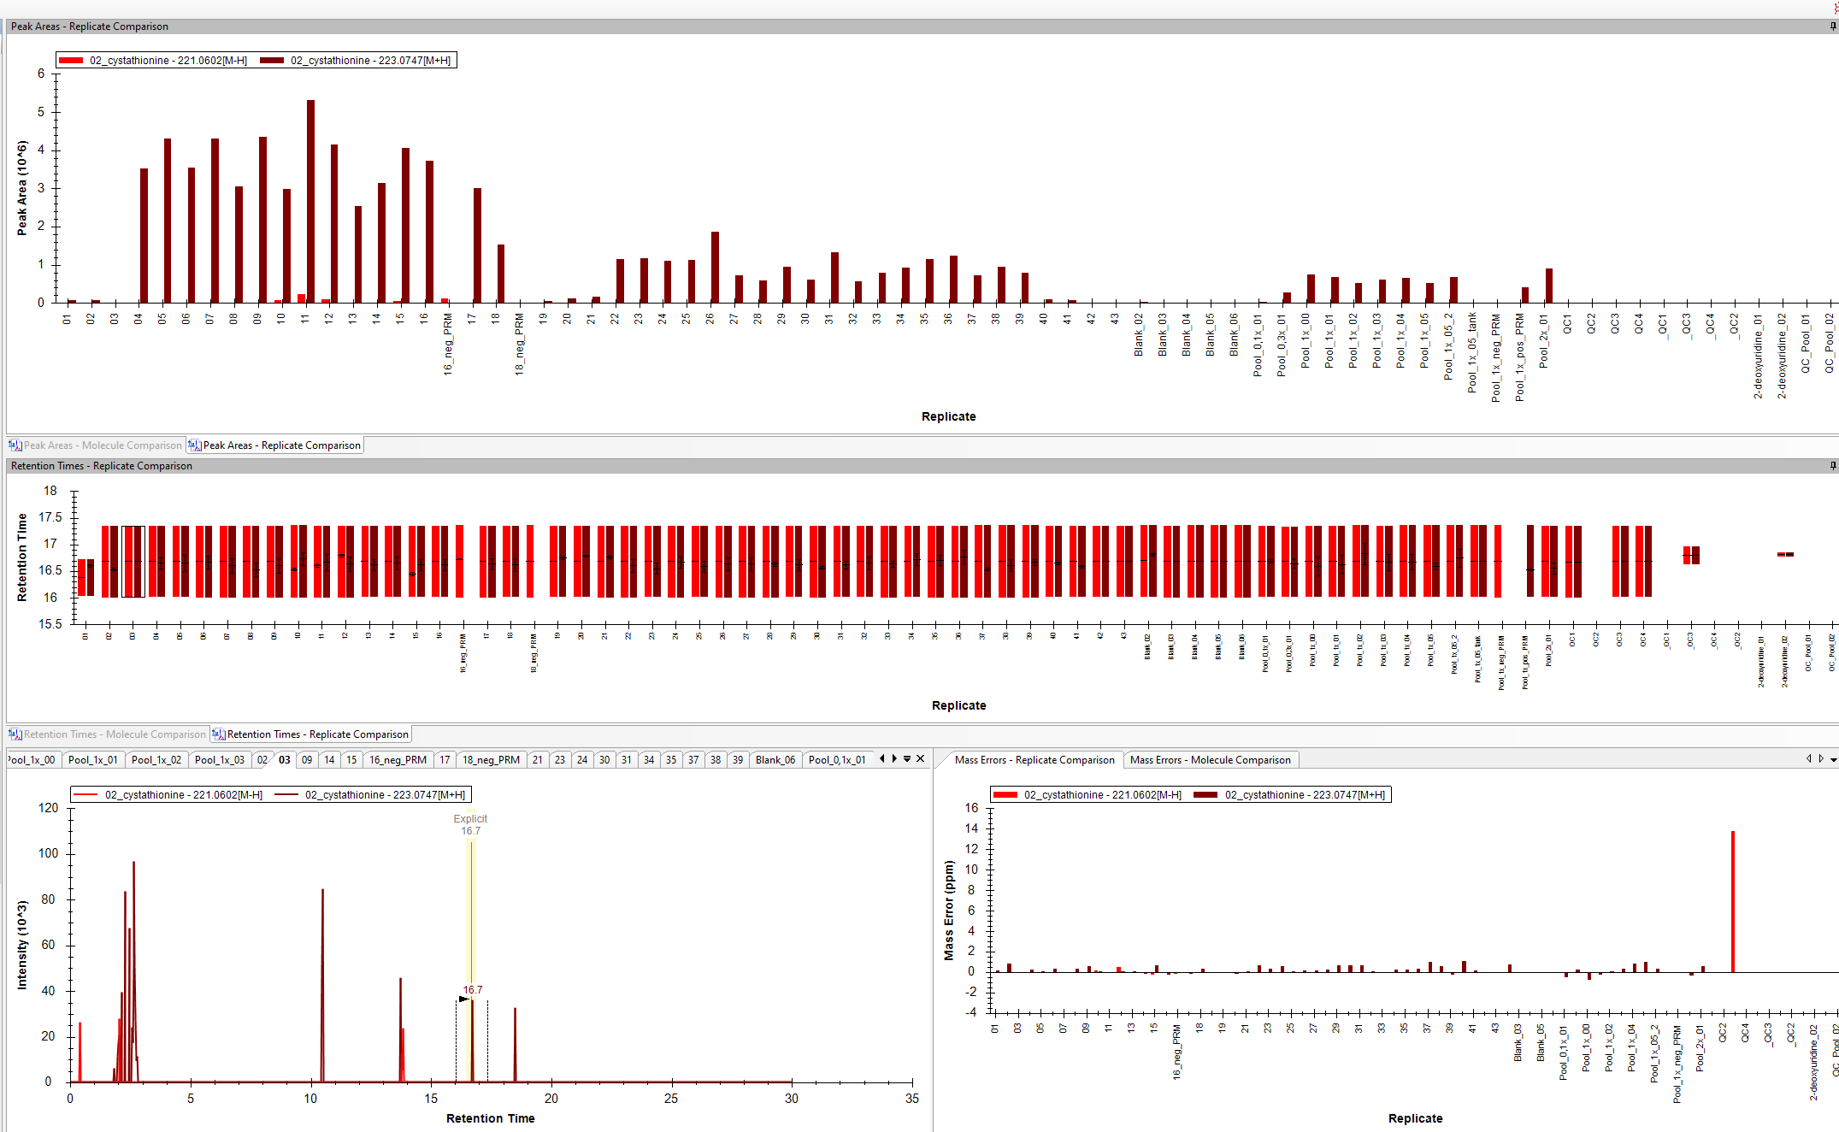
Sample 0.1X_01 was just as bad but Skyline does report a value for it.
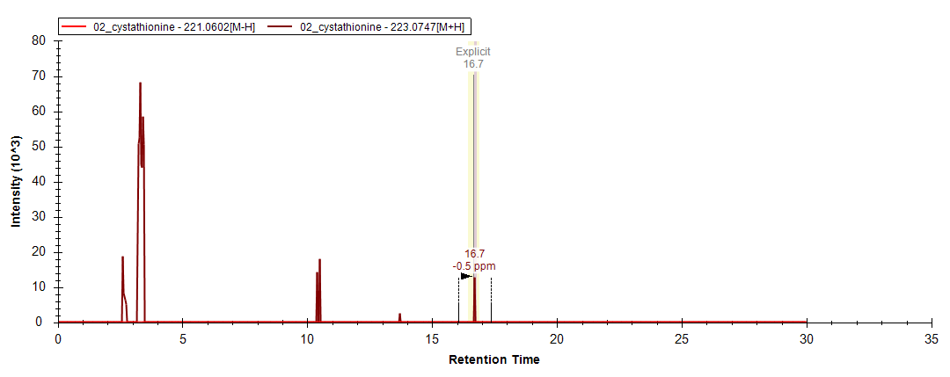

Sample Blank_02 was also low and noisy but Skyline does report a value for it.
